Página de los datasets: https://moabb.neurotechx.com/docs/dataset_summary.html#motor-imagery

Datasets usados en MIRepNet:
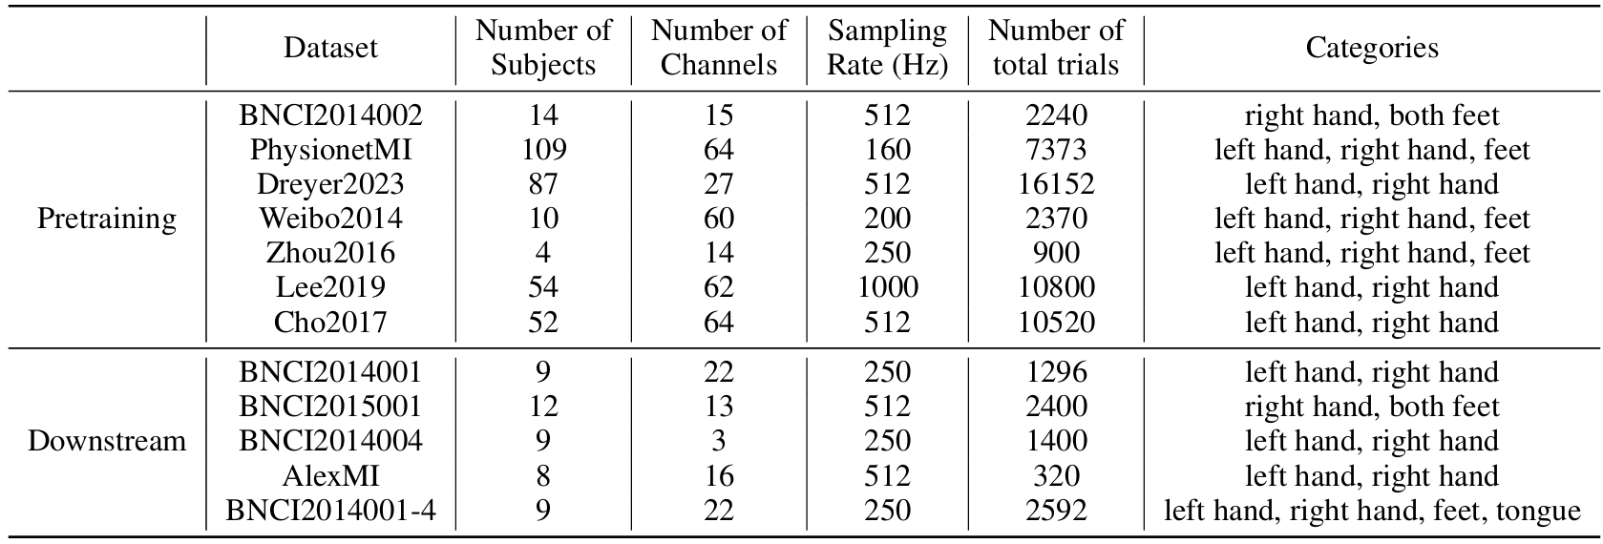

Descripción BNCI2014_002:
“The session consisted of eight runs, five of them for training and three with feedback for validation. One run was composed of 20 trials.”
“Participants had the task of performing sustained (5 seconds) kinaesthetic motor imagery (MI) of the right hand and of the feet each as instructed by the cue. At 0 s, a white colored cross appeared on screen, 2 s later a beep sounded to catch the participant’s attention. The cue was displayed from 3 s to 4 s. Participants were instructed to start with MI as soon as they recognized the cue and to perform the indicated MI until the cross disappeared at 8 s. A rest period with a random length between 2 s and 3 s was presented between trials.“
- 15 electrodos

Descripción PhysionetMI:
“This data set consists of over 1500 one- and two-minute EEG recordings, obtained from 109 volunteers.”
“Each subject performed 14 experimental runs: two one-minute baseline runs (one with eyes open, one with eyes closed), and three two-minute runs of each of the four following tasks:
- A target appears on either the left or the right side of the screen. The subject opens and closes the corresponding fist until the target disappears. Then the subject relaxes.
- A target appears on either the left or the right side of the screen. The subject imagines opening and closing the corresponding fist until the target disappears. Then the subject relaxes.
- A target appears on either the top or the bottom of the screen. The subject opens and closes either both fists (if the target is on top) or both feet (if the target is on the bottom) until the target disappears. Then the subject relaxes.
- A target appears on either the top or the bottom of the screen. The subject imagines opening and closing either both fists (if the target is on top) or both feet (if the target is on the bottom) until the target disappears. Then the subject relaxes.“

Descripción Dreyer2023:
“A recording contains open and closed eyes baseline recordings and 6 runs of the MI experiments. First 2 runs (acquisition runs) were used to train system and the following 4 runs (training runs) to train the participant. Each run contained 40 trials [1].
Each trial was recorded as follows[1]:
- t=0.00s cross displayed on screen
- t=2.00s acoustic signal announced appearance of a red arrow
- t=3.00s a red arrow appears (subject starts to perform task)
- t=4.25s the red arrow disappears
- t=4.25s the feedback on performance is given in the form of a blue bar with update frequency of 14 Hz
- t=8.00s cross turns off (subject stops to perform task)”
NOTA: Similar al BNCI2014_002 pero mostrando feedback.
Descripción Weibo2014:
“At the beginning of each trial (8 seconds), a white circle appeared at the center of the monitor. After 2 seconds, a red circle (preparation cue) appeared for 1 second to remind the subjects of paying attention to the character indication next. Then red circle disappeared and character indication (‘Left Hand’, ‘Left Hand & Right Foot’, et al) was presented on the screen for 4 seconds, during which the participants were asked to perform kinesthetic motor imagery rather than a visual type of imagery while avoiding any muscle movement. After 7 seconds, ‘Rest’ was presented for 1 second before next trial (Fig. 1(a)).”
“The experiments were divided into 9 sections, involving 8 sections consisting of 60 trials each for six kinds of MI tasks (10 trials for each MI task in one section) and one section consisting of 80 trials for rest state. The sequence of six MI tasks was randomized. Intersection break was about 5 to 10 minutes.”
- Cada una de esas 8 secciones cuenta con 60 trials → 60*8 = 480s → 8 mins.

Descripción Zhou2016:
“Every subject went through three sessions, each of which contained two consecutive runs with several minutes inter-run breaks, and each run comprised 75 trials (25 trials per class). The intervals between two sessions varied from several days to several months.”
“A trial started by a short beep indicating 1 s preparation time, and followed by a red arrow pointing randomly to three directions (left, right, or bottom) lasting for 5 s and then presented a black screen for 4 s. The subject was instructed to immediately perform the imagination tasks of the left hand, right hand or foot movement respectively according to the cue direction, and try to relax during the black screen.”

Descripción Lee2019 (entiendo que es Lee2019_MI):
“MI paradigm The MI paradigm was designed following a well-established system protocol. For all blocks, the first 3 s of each trial began with a black fixation cross that appeared at the center of the monitor to prepare subjects for the MI task. Afterwards, the subject performed the imagery task of grasping with the appropriate hand for 4 s when the right or left arrow appeared as a visual cue. After each task, the screen remained blank for 6 s (± 1.5 s). The experiment consisted of training and test phases; each phase had 100 trials with balanced right and left hand imagery tasks. During the online test phase, the fixation cross appeared at the center of the monitor and moved right or left, according to the real-time classifier output of the EEG signal.”

Descripción Cho2017:
“Subjects were asked to imagine the hand movement depending on the instruction given. Five or six runs were performed during the MI experiment. After each run, we calculated the classification accuracy over one run and gave the subject feedback to increase motivation. Between each run, a maximum 4-minute break was given depending on the subject’s demands.”
- En este dataset no son muy precisos con los tiempos.

Descripción BNCI2014001:
“At the beginning of a trial ( t = 0 s), a fixation cross appeared on the black screen. In addition, a short acoustic warning tone was presented. After two seconds ( t = 2 s), a cue in the form of an arrow pointing either to the left, right, down or up (corresponding to one of the four classes left hand, right hand, foot or tongue) appeared and stayed on the screen for 1.25 s. This prompted the subjects to perform the desired motor imagery task. No feedback was provided. The subjects were ask to carry out the motor imagery task until the fixation cross disappeared from the screen at t = 6 s.”

Descripción BNCI2015001:
- Este dataset no especifica claramente el protocolo seguido para la toma de datos (al menos que haya visto en la página que estoy viendo todos).

Descripción BNCI2014004:
“At the beginning of a trial (t = 0 s), a fixation cross appeared on the black screen. In addition, a short acoustic warning tone was presented. After two seconds (t = 2 s), a cue in the form of an arrow pointing either to the left or to the right appeared and stayed on the screen for 1.25 s. This prompted the subjects to perform the desired motor imagery task. No feedback was provided. The subjects were ask to carry out the motor imagery task until the fixation cross disappeared from the screen at t = 6s.”
- Muy similar, si no idéntico a BNCI2014001.

Descripción AlexMI:
“The start of a trial is encoded as 1, then the actual start of the motor imagination is encoded with 2 for imagination of a right hand movement, 3 for imagination of both feet movement and 4 with a rest trial.
The duration of each trial is 3 second. There is 20 trial of each class.“

Descripción BNCI2014001-4 (entiendo que estará incluido en BNCI2014001):
- Misma página y descripción que BNCI2014001.

Conclusiones (por ahora): cada trial suele durar pocos segundos (entre 8 y 10s), normalmente. Una “run” se compone de varios trials separados segundos o minutos de descanso, y suelen durar varios minutos (dependiendo mucho). Un ejemplo claro es Weibo2014: sus trials duran 8s, están bien definidas las fases y dentro de la duración del trial se incluye ‘Rest’, durante el último segundo antes de comenzar con el siguiente trial. Para la toma de datos definen “Intersecciones”, con un descanso de 5-10mins entre cada intersección, y cada una de estas conteniendo 60 trials (10 por cada tarea).

NOTA(s):
- Algunos datasets NO muestran feedback en la pantalla al usuario realizando la prueba, mientras que otros SI. Habría que sopesar en nuestro caso qué es mejor, ya que por un lado no tenemos la funcionalidad de tiempo real implementada, pero por otro lado nuestros participantes no están familiarizados con la tarea de MI, por lo que se podrían degradar los datos si no les damos algún tipo de feedback.

